PRODUCTION POSSIBILITY FRONTIER
Name of student
Name of tutor
Institution
Date

Introduction
Production possibility frontier is a tool that is used to allocate limited resources in the most economical way to achieve optimal use of the available resources. The production possibility curve can also be used to illustrate the variation in the amounts that can be produced of two different products which rely on the same resource for its production and a choice has to be made between which commodity to produce more and which commodity to be produced less for efficiency in the industry. Production possibility frontier can also be used in an economy to demonstrate the point it can efficiently produce what it can produce best as it trades with other countries for what it needs. The class activity on the rabbits and berries that the hunter and gatherer can get, given an allocated time is a clear demonstration of how an efficient production has to balance for what it can produce considering the available scarce resources (Khan, 2013). The essay will seek to explain how an economy with limited resources is able to allocate resources optimally to achieve the desired economic objectives.
In an economy that produces carrots and potatoes, it has to put its available resources into producing a good combination of goods that will efficiently utilize its scarce resources. Again, if the economy sees profitability in both goods, then it shall encounter an idea called trade-off where for any extra unit produced of a commodity for instance; for extra production of a carrot then the economy must forego another unit of producing potatoes to achieve its optimal use of its limited resources (Grafton, 2012). Availability of resources in such an economy would mean more production of potatoes and carrots, which means there will be an outward shift in the production possibility curve to reflect the new economic model. This is because, with an increase in factors of production like capital and labor, the economy can produce more goods at any point in the production possibility curve. Consequently, with the advancement in technology that reduces the cost of production and increases the purchasing parity, then more goods are produced at any point in the frontier. This shifts the production possibility curve outwardly (Beal, 2015).
The following production possibility frontier is a clear illustration of the above economy using wheat and cotton.
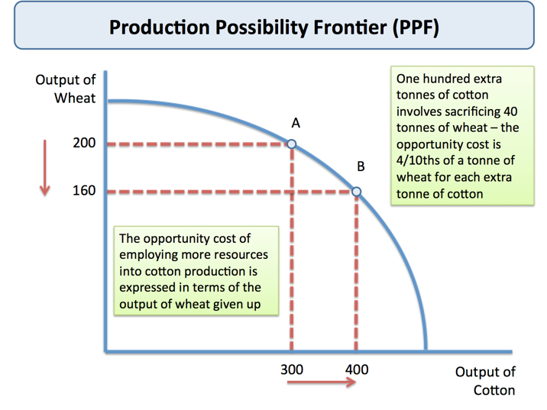

Source:https://s3-eu-west-1.amazonaws.com/tutor2u media/subjects/economics/ppf_opportunity_cost.png?
From the above illustration it can be seen that at point A, the economy can produce 200 units of wheat and 300 units of cotton. And if the economy finds it profitable to produce more cotton than wheat, then an extra 100 units of cotton means that the economy must forego 40 more units of wheat, an economic combination of 160 units of wheat and 400 units of cotton at point B. a country like these can easily concentrate and allocate more resources to the production of cotton and rely on other countries for its own other needs. Employing more resources to its usefulness use in such an economy would mean sacrificing the production of wheat to produce more cotton.
Economic growth means an increase in what an economy can produce over a given period. The ability of the economy to increase what it can produce best over a given period normally over two consecutive quarters. An increase in the economy’s production potential shifts the production possibility frontier outwardly (Grafton, 2012). An economy increases due to an increase in investment in new technology that increases the quality and quantity of what an economy can produce. PPF shifts outwardly when the economy breaks down production into separate tasks allowing machines to help in production as labor specializes in a small range of activities. Employing new methods of production such as embracing teamwork, use of computer applications such as robotics immensely increases production capacity in an economy. An increase in the labor force increases the potentiality of an economy to produce more and this shifts the PPF outwardly. Lastly, the discovery of a new line of raw material increases the production abilities of the economy. The shift in the PPF outwardly does not necessarily mean an increase in economic well-being or economic sustainability or even GDP growth. This is because an increase in economic growth could be out of a lot of sacrifices in terms of leisure time, extra time, extra resources to achieve the growth in the economy (Haynes, 2000).
The committee on economic development has related the production possibility frontier with the growth in gross domestic product, in the sense that the growth in GDP shifts the PPF curve outward, which means there is an increase in economic growth and the economy can produce more goods and services in the economy.

Conclusion
In conclusion production possibility frontier is a good economic tool that can be used to achieve a good combination of production commodities. For an economy to achieve its maximum growth while utilizing the available scarce resource, it has to allocate well and put its limited resource into good use. A country can produce what it does best and leave the rest for other countries to produce as they trade well for what they can buy from each other. PPF can be used to solve an issue of unemployment by increasing the labor force. PPF can also be used to correct the balance of payment. The PPF tool is a very important economic tool.

Reference
Grafton, R. Q. (2012). production possibilities frontier (PPF). In A Dictionary of Climate Change and the Environment. Edward Elgar Publishing Limited.
Haynes, N. L. (2000). Using the production possibilities frontier to demonstrate alternative allocations of recreation and wildlife.
Khan, S. (2013) Production possibilities curve, Khan Academy, Retrieved Https://www.youtube.com/watch?v=_7VHfuWV-Qg
Beal, D. (2015) An alternative to GDP that factors in our wellbeing TED Institute, Retrieved fromhttps://www.ted.com/talks/douglas_beal_an_alternative_to_gdp_that_encompasses_our_wellbeing.

